**Product Design Specifications Report**

**Flight Ready Electric Feed System**

Portland State University



**Group members:**

Elrod, Shayli

Garcia, Julio

Ju, Henry

Mendoza, Jonas

Sheldon, Nick

Wahl, Philip

**Academic Advisor:** Baldur Steingrimsson

**Sponsor:** Portland State Aerospace Society

DOCUMENT CONTENTS

**INTRODUCTION** **2**

**MISSION STATEMENT** **2**

**PROJECT PLAN (Top-Level)** **3**

**CUSTOMER IDENTIFICATION** **5**

**CUSTOMER FEEDBACK** **5**

**PDS** **6**

**CONCLUSIONS** **8**

**ATTACHMENTS** **8**

### 

### INTRODUCTION

Portland State Aerospace Society (PSAS) requires the production of a device that can be used to increase fluid pressures in both the Liquid Fuel Engine Test Stand (LFETS) and PSAS liquid fuel rockets in flight. The Flight Ready Electric Feed System (EFS) is an electronically controlled pump system to be designed for the Launch Vehicle 4 (LV4). This project has been proposed by PSAS in order to make the use of lightweight, low-pressure composite propellent flight tanks possible. As opposed to utilizing a more traditional high pressure 'blow down" system, an EFS will be used to provide the necessary pressure to pump the propellants into the engine. Design and manufacturing of the EFS will be a part of a senior capstone project involving six Mechanical Engineering students. This approachable and affordable alternative to a pressurized tank is a challenging and innovative task for an amateur rocket design.

### MISSION STATEMENT

“To provide affordable, lightweight propulsion system technology increasing the capabilities of amatuer rocketry and student education.”

### 

### PROJECT PLAN (Top-Level)

The pump design will utilize electric drive shafts to introduce mechanical work into the system in order to produce a pressure increase. Each housing will be optimized for the required pressure of two independent fluids. The pump design will be optimized for flight capability, utilizing a compact lightweight casing to enclose individual chambers which separately increase the pressure of Isopropyl Alcohol and Liquid Oxygen. The pump will be powered by an onboard Lithium Ion battery pack, providing DC current to an electric inverter. AC converted current will power the brushless motors to provide shaft power in order to rotate off the impellers within the system. As the system provides rotational energy, the pressure of the incoming propellants will increase from 45 PSI to 500 PSI as the impellers increase the propellant potential energy.

The manufacturing process will begin with 3D rendering in SolidWorks to create the shape and layout of the housings and motors. A machinable prototype needs to fit within specified dimensions of the airframe module which will house the onboard EFS. A functional design will be followed by ANSYS vibrational and thermal analysis to show evidence of structural integrity. Once the design has been analytically verified, it will be approved and passed on to the CNC machine shop for physical fabrication. Initial machine prototypes will be machined out of inexpensive plastics for trial mock-ups before any machining out of metal will begin.

The corrosive properties of liquid oxygen will limit the material options for pump component which will come into contact with it. 304 Stainless steel is the most common metal alloy used for liquid oxygen components, and its availability makes it a logical candidate for material selection. In addition, research will be performed on the feasibility of using alternative materials that may be more cost effective and easier to machine, such as aluminum alloys.

Tolerance testing will begin upon completion of machined parts in either plastic or metal. All dimensions will be compared against the CAD model for machining accuracy and precision. Once a metal casing has been created leak testing will check for fitment of the final assembly. The pump will be assembled and then filled with water, up to 1000 psi, to search for any leaks in the system. Continued system testing will research durability against vibrational and acceleration force as the pump will be subjected to a harsh launch environment. It is imperative that the system is not compromised so the rocket can achieve consistent thrust during flight.

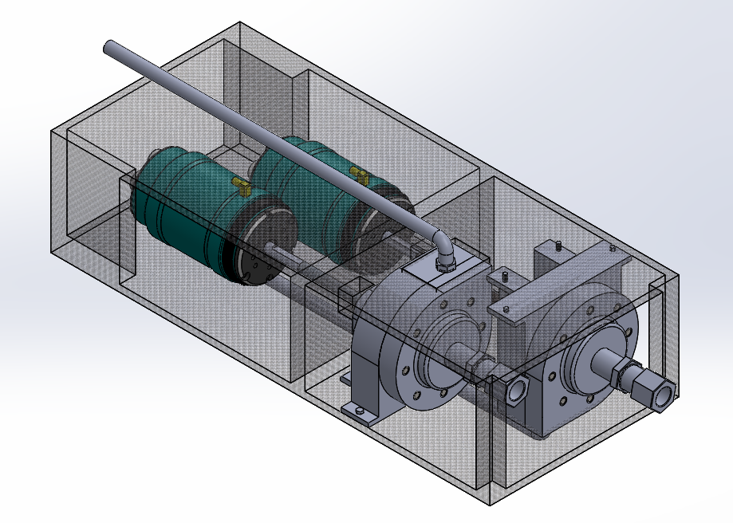

Upon completion, the desired deliverable is a tested electronically controlled pump that is suitable for successful use during flight. Crucially, the pump and associated system components must be compatible both propellants and ensure absolute fluid separation at all points within the system. Cross-contamination of fluids will be considered a design failure and impose a major safety risk. The minimum lifespan without significant overhaul is ten full-length engine test fires. Surpassing ten fires is preferred if at all possible. The pump and its related systems should be embedded with sensors for required data collection, as this testing data is also a deliverable. The milestone timeline for the project can be seen in Table 2 (see attachments).

### CUSTOMER IDENTIFICATION

Portland State Aerospace Society will be sponsoring this capstone project and is responsible for all the given requirements. In addition, the Oregon NASA Space Grant Consortium (OSGC) will also be sponsoring our Flight Ready EFS capstone after winning an Undergraduate Team Experience Award Program grant. This additional sponsor will add extra requirements to be fulfilled by the capstone team such as a project presentation to the OSGC board as publishing project documentation. The requirements from both customers are outlined in Table 3 (see attachments).

### CUSTOMER FEEDBACK

The Flight Ready EFS Capstone group will provide a weekly update to PSAS through a short presentation at the general meetings. This will ensure all progress is shared with the customer and all designs are to be to review as they progress. Use of funds will involve direct communication with OSGC on a per part basis. All purchase requests will be review by the team’s Principal Investigator and then sent off to OSGC for reimbursement. All declined part requests will undergo a secondary review in order to reselect a similar part which can be purchased.

### PRODUCT DESIGN SPECIFICATION (PDS)

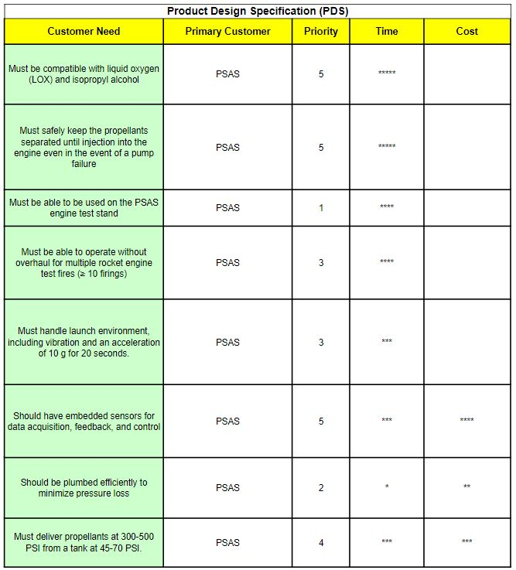

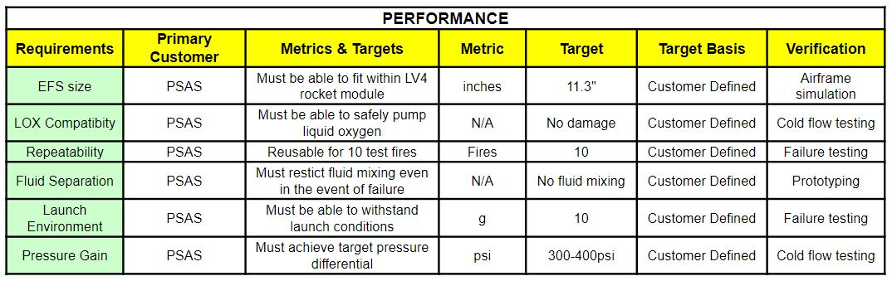

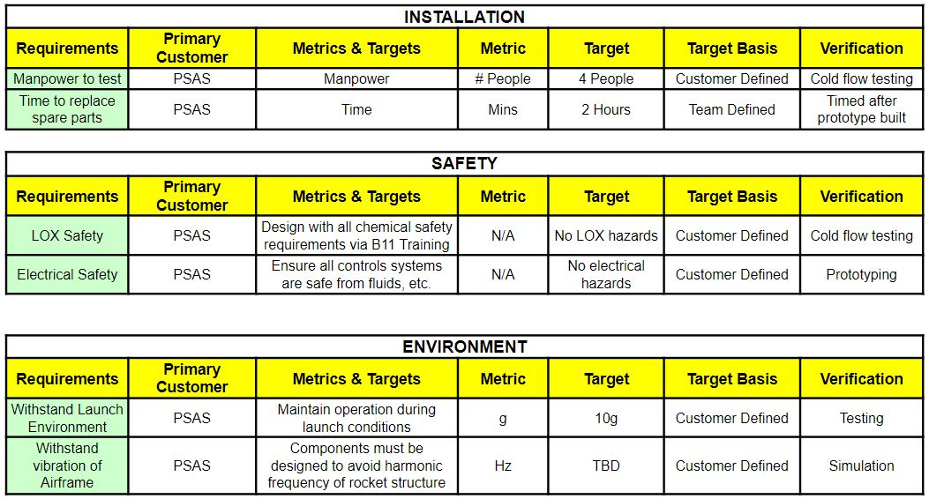

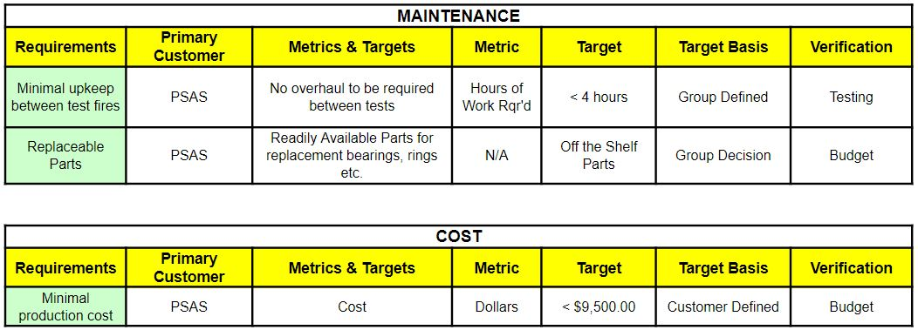

### CONCLUSIONS

The Flight Ready Electric Feed System, upon completion, will be a major accomplishment for the amateur aerospace community. This project will further develop research performed by previous and concurrent PSU Capstone teams associated with the liquid propulsion team within PSAS. Over the next few months, we anticipate developing a cryogenic, electronically controlled, propellant delivery system for Launch Vehicle 4 as specified by our Capstone Sponsor, PSAS. By the end of the school year will be presenting our findings, prototype, and publish all documentation related to the project.

### ATTACHMENTS

*Table 1: Electric Feed System Project Budget*

|  |  |  |  |  |
| --- | --- | --- | --- | --- |
| **Item** | **Description** | **Vendor** | **Award Amount** | **1.5:1 Cost Share** |
| **Cost Share** | | | | |
| In-Kind AY effort | Dr. Mark Weislogel donating his time working as PI on Project | Portland State University |  | $6,556 |
| **Award Budget** | | | | |
| 304 SS Steel | The raw material used to machine pump housing | McMaster-Carr | $800 |  |
| Tooling | Pump House machine tooling | Western Precision Products Inc | $1,400 |  |
| 6061 Aluminum | Raw Material to create EFS Airframe Structure | McMaster-Carr | $200 |  |
| 304 SS Steel | ¼” x 24” TGP Precision Shaft | Metals Depot | $10 |  |
| Impeller | Rotational Impellers for propellants | Shapeways | $200 |  |
| ISO Plumbing | Various plumbing fittings for alcohol | Home Depot | $100 |  |
| LOX Plumbing | Various LOX compatible fittings | AcmeCryo | $300 |  |
| Aluminum Piping | ½” Aluminum piping for plumbing | Metals Depot | $100 |  |
| Seals | Metal C-Ring Internal Pressure Face Seals | Parker | $30 |  |
| Liquid Oxygen | 40 Gallons of LOX for testing | Airgas | $200 |  |
| Liquid Nitrogen | 40 Gallons of LN for cryo testing | Airgas | $200 |  |
| Electric Motor | Brushless Motor for shaft drive | Hobbyking | $150 |  |
| Heat Sink | Heat Sink for Brushless motor | Amazon | $25 |  |
| Arduino | Arduino to Controlling pump | Amazon | $50 |  |
| Sensing Equipment | Pressure Transducers and flow meters for fluid monitoring | Omega | $500 |  |
| **Total Direct Costs** |  |  | $4,265 | $6,556 |
| Total Indirect Costs |  | 48.50% | $2,069 | $3,180 |
| **Total Project Costs** |  |  | **$6,334** | **$9,736** |
| **Cost Share Ratio** | 1.537 |  |  |  |

*Table 2: EFS Completion Timeline*

|  |  |
| --- | --- |
| **Week** | **Milestone Description** |
| 1 - 3 | Research and locate budget line items to optimize spending. Discus pump design process to dictate the purchase sequence. |
| 4 - 6 | Finalize design for preliminary prototyping with 3D printing and mock testing |
| 7 - 10 | Integrate Control system with proven test design |
| 11 - 15 | Coordinate Electric Feed System design with Engine Test Stand and Airframe |
| 16 - 20 | Begin manufacturing process for steel housing, plumbing, and airframe fixture |
| 21 - 22 | Testing cryogenic compatibility, fluid leak, and durability to cycle usage |
| 23 - 25 | Department testing with Test Stand and Airframe |
| 26 - 27 | Finalize Electric Feed System Design |
| 28 - 30 | Organize project material for finalized report and presentation |

*Table 3: Customer Requirements for PSAS and OSGC*

|  |  |
| --- | --- |
| **PSAS Requirements** | **NASA OSGC Requirements** |
| Must be compatible with liquid oxygen (LOX) and isopropyl alcohol | Citation of OSGC as a source of funding in all publications |
| Must safely keep the propellants separated until injection into the engine even in the event of a pump failure | Complete list of resulting publications |
| Must be able to be used on the PSAS engine test stand | Final budget |
| Must be able to operate without overhaul for multiple rocket engine test fires (≥ 10 firings) | Report on project outcome |
| Must handle the launch environment, including vibration and an acceleration of 10 g for 20 seconds. | Presentation of results at the OSGC Student Symposium in (Nov 2019) |
| Should have embedded sensors for data acquisition, feedback, and control |  |
| Should be plumbed efficiently to minimize pressure loss |  |
| Must deliver propellants at 300-500 PSI from a tank at 45-70 PSI. |  |